Bayview Hospital (2014) Ltd
Breastfeeding Patient Leaflet
Benefits of Breastfeeding
There are many benefits for both you and your baby from breastfeeding.
Contains all the nutrients for optimal growth and development
Protects against infection and other diseases e.g. tummy upsets and diabetes
It’s free, convenient, sterile, served at the right temperature, and environmentally friendly
Reduces the risk of ovarian, uterine, and breast cancer
Healthier bones and teeth
Reduces risk of baby developing eczema, asthma and other allergic disorders
Helps Mum burn up to an extra 500 calories a day

Formula Feeding of healthy breastfeed babies is best avoided because:
- It can interfere with the protection against infection that colostrums/breast milk is creating in the baby’s gut.
- For families with a strong history of allergies, formula can create an allergic response in your infant.
- Formula is more slowly digested than breast milk and increases the time between feeds. This may prevent full drainage of your breasts at feeds and give less stimulation to your breast, thus often leading to a reduced breast milk supply.
Getting Started
At Bayview, we encouraged skin to skin contact between mother and baby especially in the first hour after baby’s birth. This helps calm baby, keep him/her warm, and help adapt to life outside of the womb. This is also a great time to start breastfeeding. Right after birth most babies are alert and want to feed. Your midwife can help you with this.
Your baby will be happier if you keep him near you and feed whenever he is hungry. This will help you breast produce plenty of milk.
After the initial alert period some babies become very sleepy for the next 24 hours or so. This may be due to the birth experience and/or pain relieving drugs given to you during labour. If this happens colostrums may need to be expressed and given to baby if he/she is not feeding especially after the first 24 hours. The early use of teats and dummies are discouraged as this can interfere with breastfeeding.
By the second day after birth, babies have periods of wishing to feed very frequently, especially at night. This is normal and is how your baby is helping your milk supply establish by stimulating you breast regularly. A baby can breastfed between 8-12 times, or more in a day!
Get some rest during the day will help you manage these night time feeds. Reducing or limiting the number of visitors you have during the day may also help.

How to Breastfeed
The 2 most important skills to master in order to successfully breastfeed are:
- The correct positioning of baby and yourself.
- Ensuring the baby is attached to the breast correctly (latch)
Breastfeeding Positions
There are 5 feeding positions. You should become familiar with each one before you go home from hospital. The cradle and cross cradle are the most commonly used positions, but it good to learn all the other positions as each has a beneficial reason for use, e.g. football position - good for people with large breast or feeding a small baby. Lying on your side – use this when you are tired, for night feeds as you can doze while baby feeds or have ‘stitches’ and find it difficult to sit.
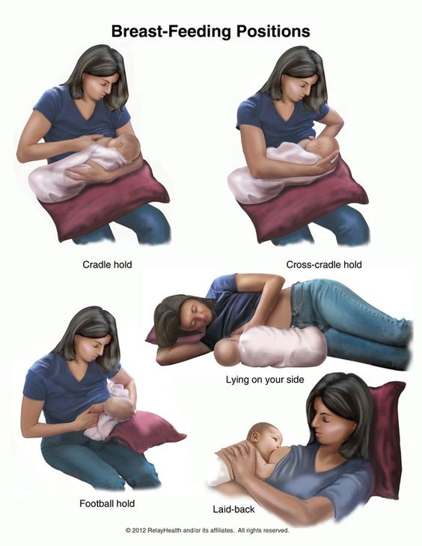
The Latch
Your baby needs to get a big mouthful of breast from underneath the nipple. Placing your baby turned towards you with his nose level with your nipple. This will allow him to reach up and attach to your breast.

How Breastfeeding Works
The more your baby feeds, the more milk you make. When your baby sucks at the breast, hormones are released. These hormones make the milk and cause the milk to ‘let down’ or flow.
The first milk (colostrum) you produce looks thick and yellowish. Colostrum is important for your baby as it contains substances to nourish and protect your baby from disease. Only small amounts of colostrums are produced at first as this is all your baby needs. The milk gradually becomes thinner and more watery looking and the amount you produce increases. This is normal; your milk contains everything your baby needs to grow and satisfy hunger.
n
Signs your milk is flowing
A change in your baby’s sucking rate from rapid sucks to suckling and swallowing rhythmically, at about 1 suck per second. While feeding on one side your other breast may start to leak milk. Some mothers feel a tingling sensation in the breast.
Your milk flow can be affected by emotions like anxiety, embarrassment, tension, and extreme tiredness. Being relaxed when breastfeeding helps your milk flow.
How long to feed your baby?
The length of time a baby feeds will vary. A newborn baby is often sleepy and may need waking during a feed and encouragement to fully drain the breast. (having your baby unwrapped during feeds may help).Most babies take both breast at each feed. If you feel pain after you start to feed, your baby is not attached correctly and this may cause sore or cracked nipples. If pain is experienced put a clean finger into the side of your baby’s mouth between the gums to break the suction. Gentle take baby off the breast and reposition and reattach him/her. After the feed you breast should feel lighter with no lumps.
Signs that your baby is feeding well
- Your baby is well latched and has the majority of the dark skin around the nipples in his/her mouth.
- It does not hurt when your baby feeds (although the first few sucks may feel strong).
- If you see the dark skin around your nipple, you should see more dark skin above your baby’s top lip than below your baby’s bottom lip.
- Your baby’s cheeks stay rounded during the feed.
- Your baby rhythmically takes long sucks and swallows (it is normal for your baby to take breaks from time to time).
- Your baby finishes the feed and comes off the breast on his or her own.
- In the first few days after birth, fully breastfed babies will have 1-2 wet diapers a day and at least 1 bowel movement. (meconium, a thick dark green stool). Once your baby is receiving mature breast milk then expect:
- Five or more wet diapers every 24 hours
- Clear or pale urine
- Soft, watery yellow bowel action – at least 2-3 times per day for the first 4-6 weeks
- An alert healthy baby with good skin tone
- An average weight gain of 150gms (5ozs) or more per week in the first 3 months

Top Tips for Breastfeeding
- Seek help to ensure position and attachment is correct. Breastfeeding is a learnt skill for you and your baby, don’t feel embarrassed to ask for help and guidance. This will prevent problems.
- Breastfeed exclusively, giving other food and drinks will reduce your milk supply
- Respond to your baby for night feeds, night feeds are essential to maintain your milk supply.
- If you give your baby less mum’s milk, it will not protect your baby against illness as effectively
- Try not to give dummies/pacifiers before breast feeding is established. This can lead to nipple confusion. Also your baby will be less likely to feed when they need to, so won’t take in as much milk.
- Try not to compare your baby with a formula fed baby; they will feed very differently.
- You can never over feed a breastfed baby! So it’s fine to offer the breast to comfort your baby.
- Although you cannot see what your baby is getting, you can tell they are getting enough milk if they are settled following the feeds and have sufficient wet and dirty diapers.
- Don’t be scared to ask for help. It can take a while to become confident. Ask your paediatrician or speak to a midwife at the hospital.
How Dads can help with Breastfeeding
Research shows that mothers breastfeed for longer when partners are supportive.
- Go to antenatal classes with her so you can remind her of the tips and tricks you learnt at class.
- Bring her snacks and drinks while she is feeding.
- Give her a break after she has finished breastfeeding. Do some skin to skin contact with baby while she relaxes.
- Try to make life easier. It’s the little things that make a big difference. E.g. preparing meals that fit around your baby’s feeds.
- Emotional support. Encourage her to continue breastfeeding especially in the early days
- It can be really hard in the early days when babies can take up all your energy. Try to make time for each other when you can. Do little things to make each other feel cared for and included.

Common Breastfeeding Challenges
Here are some common challenges that breastfeeding mothers sometimes encounter and the solutions to minimize discomfort.
Sore Nipples
Vigorous sucking in the early days or improper latching on may cause sore or cracked nipples.
- Try a new feeding position
- Air-dry your nipples after feeding
- Rub your own milk around your nipples
- Wear only cotton clothing
- There are over the counter creams available e.g. Lanolin that can be used to help protect and repair, and are safe for baby
- Intermittent use of nipple shields can help relieve some of the discomfort at the beginning of the feed.
Remember if your nipples are cracked they may bleed. This is not harmful to the baby but your baby can vomit up the blood straight after the feed (bright red) or later (dark red).
Engorgement
Your milk comes in about 72 hours after birth. A degree of fullness may be experienced at this time from an accumulation of milk as your breast adjusts to your baby’s needs.
Engorgement is caused by a build-up of blood, milk and other fluids in the breast. This can occur when your milk first comes in or if the breasts are not drained well during a feed.
- Ensure your baby latches on correctly to the breast
- Feed your baby often without limiting the time at the breast.
- Ensure your baby drains the first breast before offering the second side.
- Avoid the use of a dummy/pacifier or complimentary feeds (i.e. formula)
- If your breasts are very full you may need to express a little milk to soften the areola so your baby can latch on well.
Treatment
- Take a hot shower, massage your breast towards the nipple to allow some of the milk to leak out.
- Place cold packs or a cold wet washcloth on your breast to soothe the discomfort resulting from the swollen tissues.
- Cold single cabbage leaves placed in your bra can also help soothe the breast.
- If the breasts are full and heavy 24 hours after the milk comes in, a one-off complete drainage of the breast is necessary. This can be done using a breast pump or by hand expressing.
- Seek professional help to ensure the condition resolves.
Blocked Ducts
A blocked duct causes a lump that is tender or painful because the milk is building up behind the blockage
- Ensure correct positioning and attachment
- Alter positions during feeding to include the cradle, football or lying on your side.
- Place a warm, wet cloth and massage the area as your baby feeds
- Avoid tight or restrictive clothing e.g. bra
- Avoid pressing or holding one area of the breast too tightly, especially close to the nipple.
- Seek professional help if the blocked duct has not cleared within 24 hours
Mastitis
Mastitis is a preventable breastfeeding problem. It occurs when there is a blockage of milk in the milk duct. Some milk may leak into the surrounding tissues causing inflammation and infection.
Signs and Symptoms
- The breast has a red, painful area.
- An aching flu-like feeling such as fever, feeling shivery and generally unwell
Seek medical help as soon as possible if you think you have mastitis.
Treatment
- Drain the breast frequently. Attach the baby to the affected side first.
- Cool packs from the refrigerator (not freezer) or cool cloths can relieve discomfort and pain.
- Anti-inflammatory medication e.g. ibuprofen, will reduce the inflammation and pain
- Paracetamol may be taken to ease discomfort and fever
- It is important to get extra rest. You may need household help to achieve this.
- You will need to take antibiotics for 10-14 days.
- If it is too painful to feed, express your breast using a pump or hand expressing.
- Seek advice from your doctor to determine a cause and prevent reoccurrence.
References
Government of Western Australia, North Metropolitan Health Service: “Women and New Born Health Serve: Information Leaflet on Breast Feeding and Breast care: http://www.kemh.health.wa.gov.au/brochures/consumers/wnhs0560.pdf
National Health Service UK: Patient Leaflet “Off to the Best Start”: http://www.clch.nhs.uk/media/163989/start4life_off_to_the_best_start_leaflet.pdf
UNICEF the Breast Friendly Initiative: http://www.breastmilk.co.uk/pdfs/Unicef%20-%20Guide%20to%20breastfeeding.pdf

